Module 4

Assignment 1

Entities:

* Member
* Student
* Teacher
* Librarian
* Book
* IssuedBook

Entities with respective attributes:

* Member

Attributes:

member_name

member_id

type

* Student

student_id

stream

branch

academic_year

* Teacher

department

expertise

employee_id

* Librarian

name

employee_id

* Book

name

ISBN

genre

author

title

publisher

* IssuedBook

name

member_id

return_date

issue_date

* Library

number_of_books

seating_capacity

Assignment 2

Entities:

* Classroom
* Teacher
* Student

Entities with respective attributes:

* Student

name

student_id

stream

branch

academic_year

* Teacher

name

department

expertise

employee_id

* Classroom

division

seating_capacity

Assignment 3

* Customer
* Product
* Shopping Cart
* Order

Entities with their respective attributes:

* Customer:

name

mobile_number

email_id

customer_id

* Product:

name

id

price

description

picture

* ShoppingCart:

list_ordered_item

list_ordered_item_quantity

list_ordered_item_price

list_ordered_item_cost

list_ordered_item_name

list_ordered_item_id

customer_id

* Order:

order_id

date_of_purchase

shipping_address

customer_id

customer_name

list_ordered_item

list_ordered_item_quantity

list_ordered_item_price

list_ordered_item_cost

list_ordered_item_name

list_ordered_item_id

Assignment 4

class Employee:

def __init__(self,FirstName,LastName,Pay):

self.first = FirstName

self.last = LastName

self.salary = Pay

self.email = self.first + '.' + self.last + '@company.com'

def details(self):

print(self.first,self.last,self.salary,self.email)

emp_1 = Employee('Mohandas','Gandhi',50000)

emp_1.details()

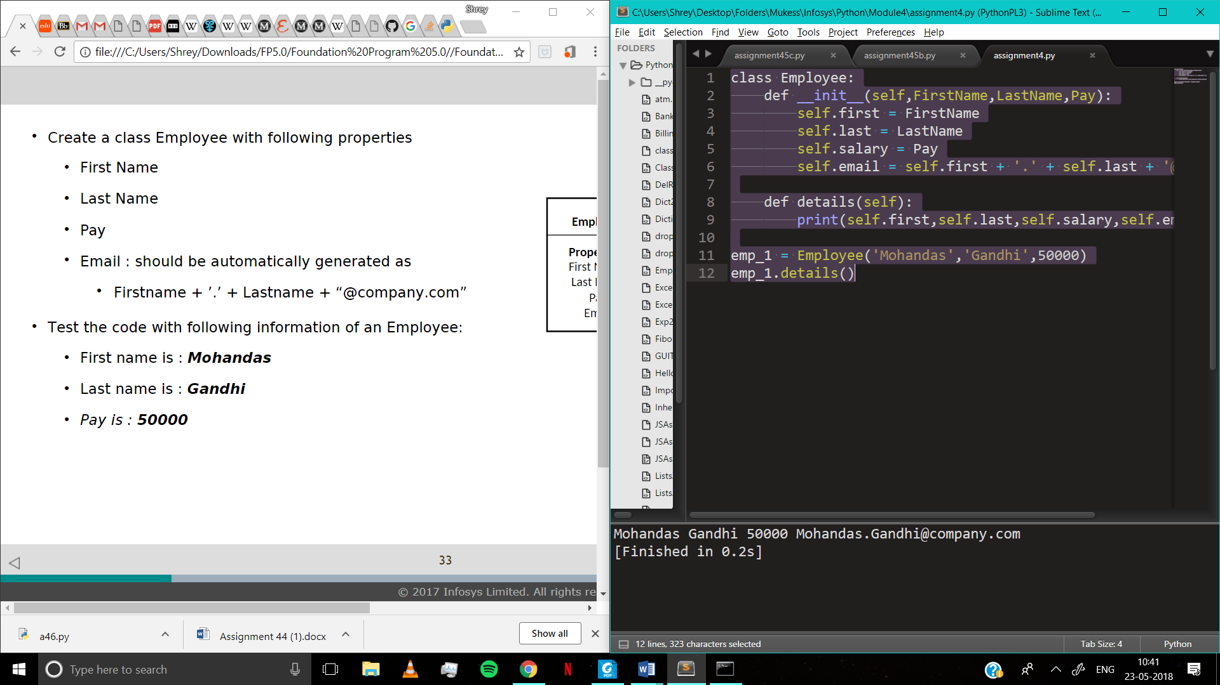

Assignment 5

class Employee:

def __init__(self,FirstName,LastName,Pay):

self.first = FirstName

self.last = LastName

self.salary = Pay

self.email = self.first + '.' + self.last + '@company.com'

def details(self):

print(self.first,self.last,self.salary,self.email)

def getEmail(self):

print(self.email)

def getFullName(self):

print(self.first + self.last)

def getPay(self):

print(self.salary)

emp_1 = Employee('Mohandas','Gandhi',50000)

emp_1.details()

emp_1.getEmail()

emp_1.getFullName()

emp_1.getPay()

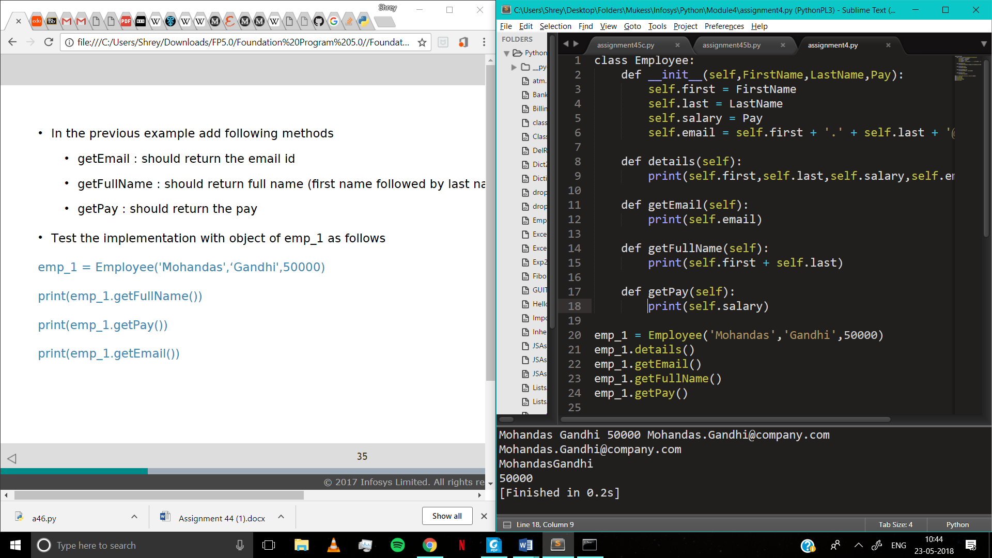

Assignment 6

The risk associated with the following:

• The balance can be set to a very high or low value accidently

• The balance can be accessed or changed by the user of the class.

• The balance can be set to non-permitted value.

SOLUTION :

Make balance a private variable which is __balance

def __init__(self, initial_amount):

self.__balance = initial_amount

Assignment 7

class Dog:

def __init__(self, name):

self.name = name

def add_trick(self, trick):

self.tricks=trick

def print(self):

print(self.name,self.tricks)

d = Dog('Fido')

e = Dog('Buddy')

d.add_trick('roll over')

e.add_trick('play dead')

d.print()

e.print()

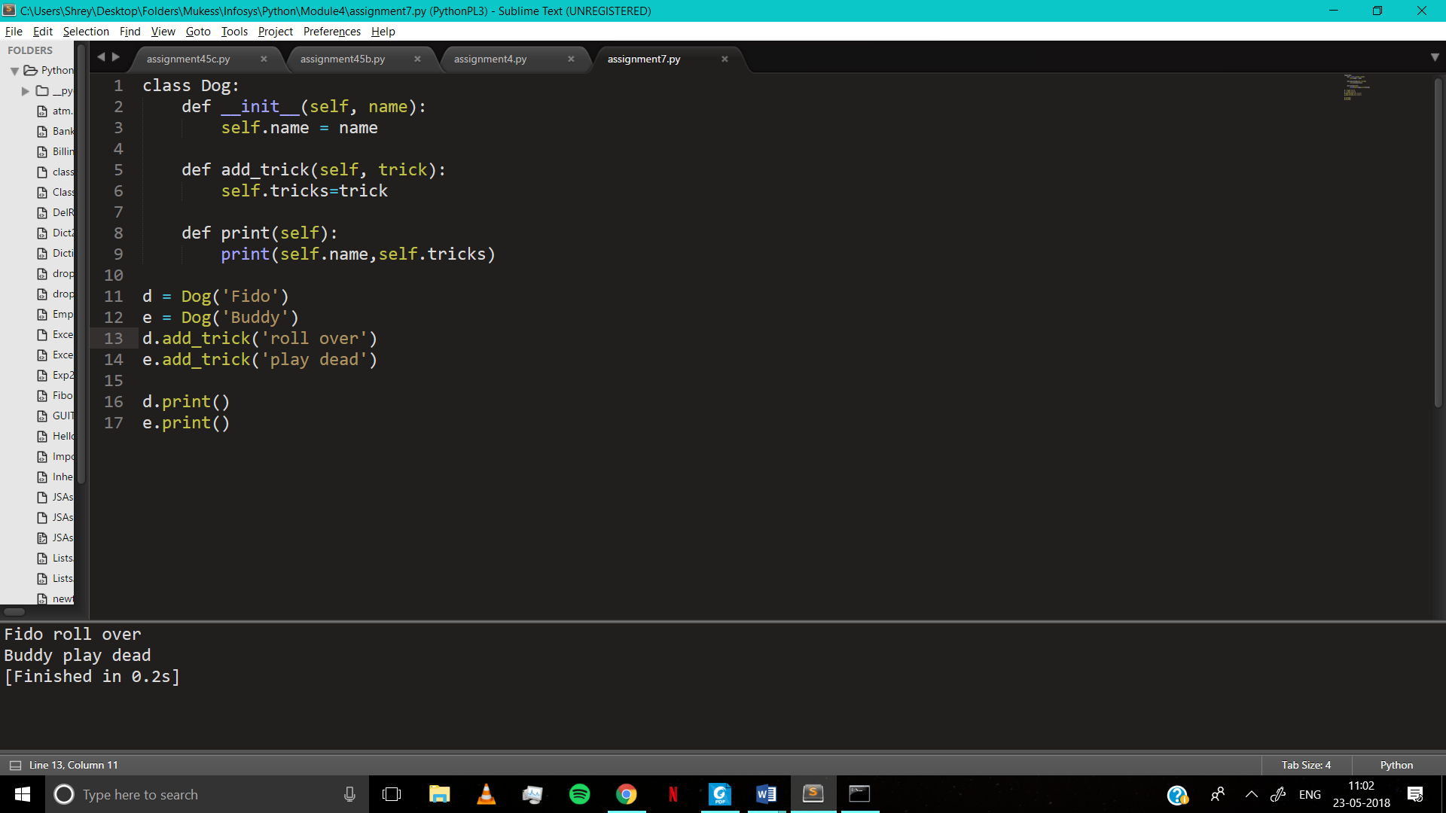

Assignment 8

class Employee:

@classmethod

def from_string(cls,emp_str):

cls.fname,cls.lname,cls.pay=emp_str.split('-')

return cls.fname,cls.lname,cls.pay

def __init__(self,first,last,pay):

self.firstname = first

self.lastname = last

self.pay = pay

def print(self):

print(fname,lname,pay)

emp_1_str = 'John-Abraham-50000'

emp_1 = Employee.from_string(emp_1_str)

emp_1 = Employee.from_string(emp_1_str)

print(emp_1)

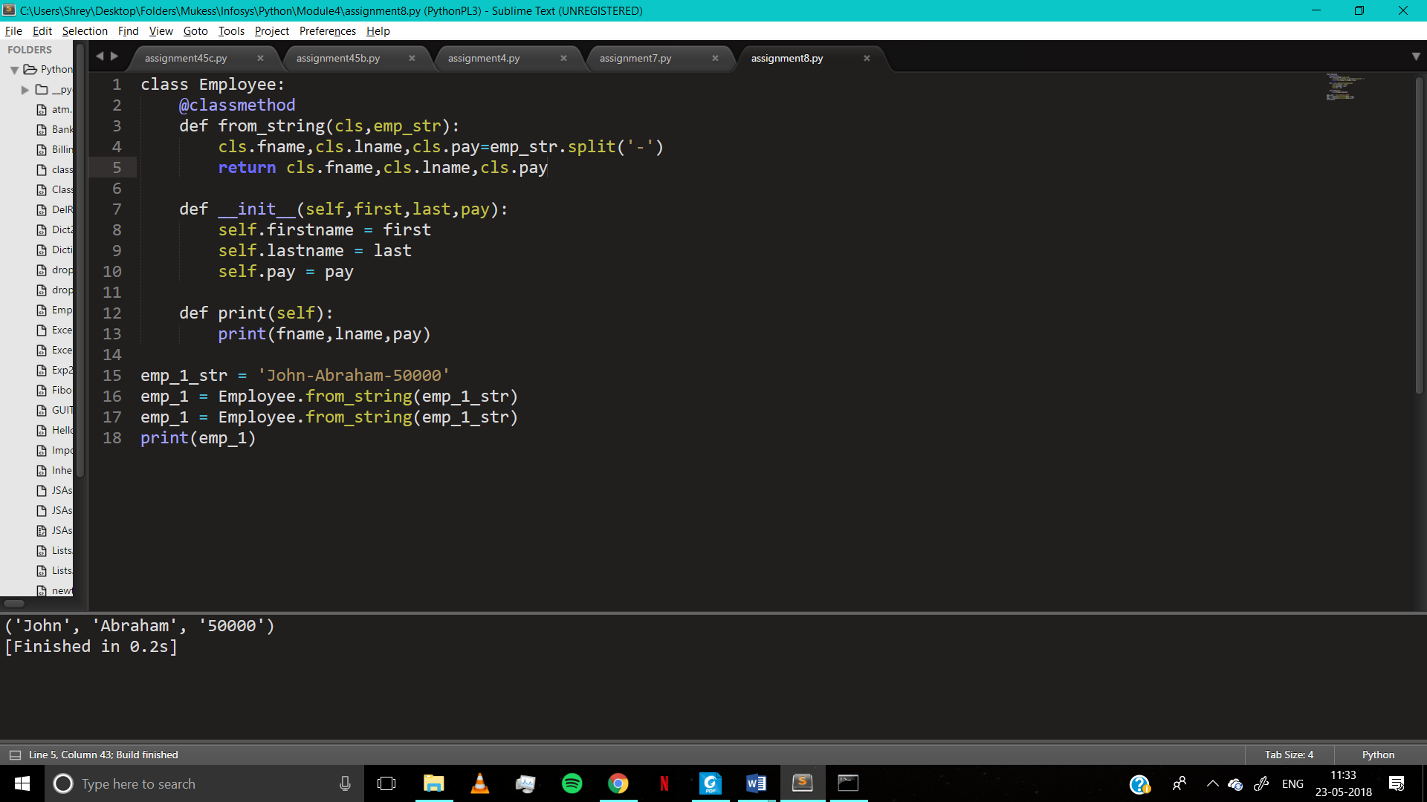

Assignment 9

class Store:

__item_count = 100

#adds to count to __item_count

def addItem(self,count):

self.__item_count = self.__item_count + count

#subtracts count from __item_count

def issueItem(self,count):

self.__item_count = self.__item_count - count

#returns __item_count

def getItemCount(self):

return self.__item_count

counter1=Store()

counter1.addItem(2)

counter1.issueItem(1)

print(counter1.getItemCount())

counter2 = Store()

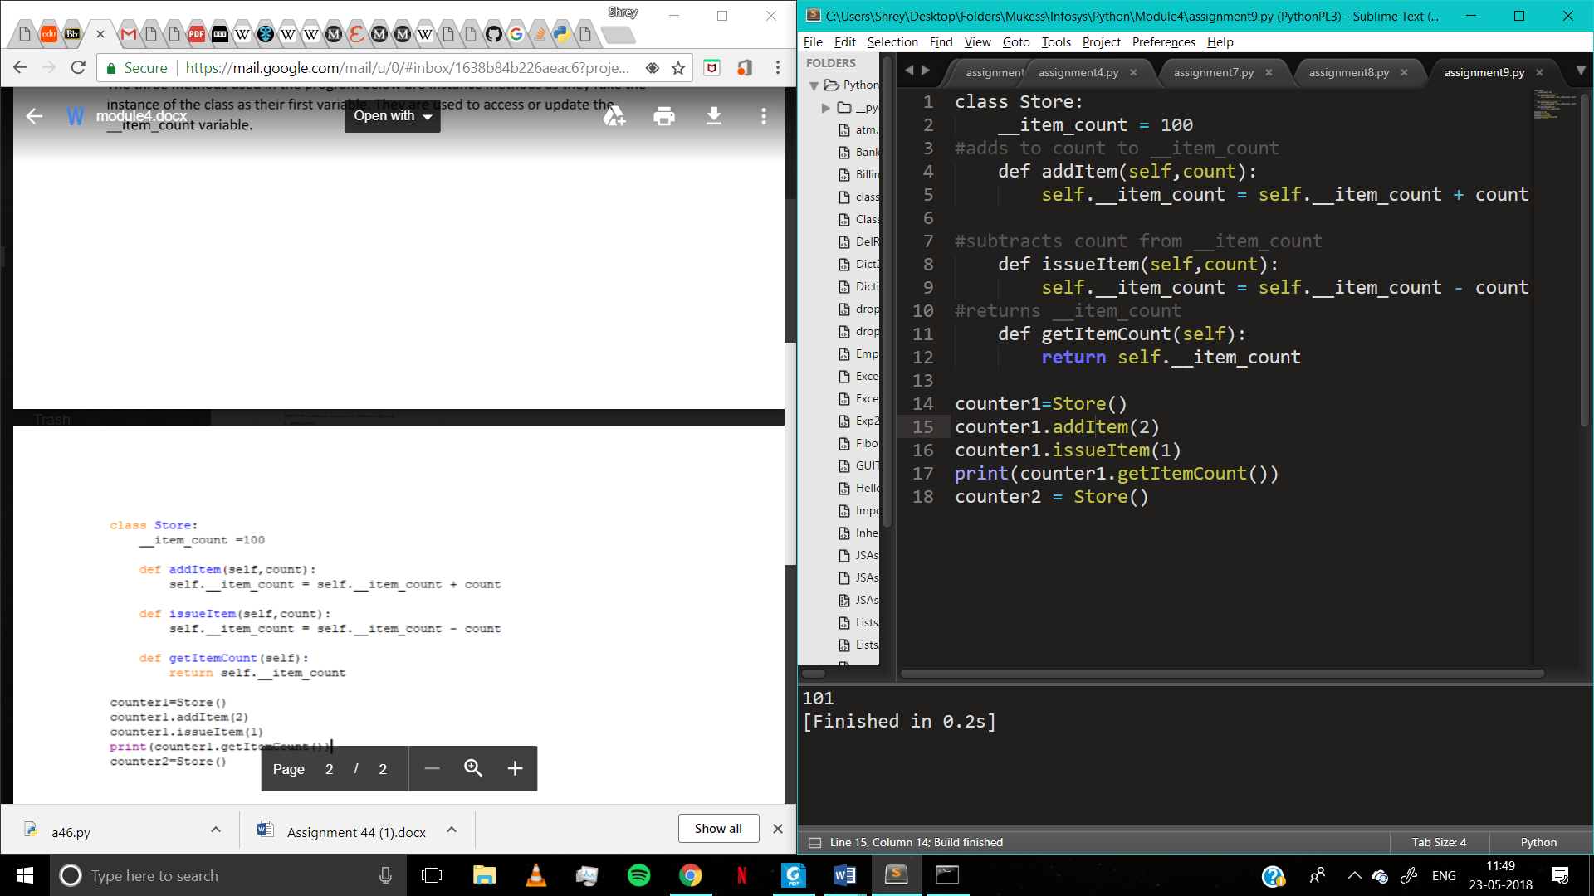

Assignment 10

The objects have knowledge about class from which it is instantiated but the class has no knowledge of the objects that have been created. Python runtime creates only one copy of static and class members and all instances share the same; whereas individual copies of instance members are created with respective objects. The instance handle, self is not available inside class and static methods.

Assignment 11

class Book:

title = ""

author = ""

publisherInfo = ""

def __init__(self,title,author,publisherInfo):

self.title = title

self.author = author

self.publisherInfo = publisherInfo

def print(self,book):

print("Author:", self.author)

print("Title:", self.title)

print("Publisher Info:", self.publisherInfo)

b = Book("Harry Potter","J.K.Rowling", "Penguin")

b.print(b)

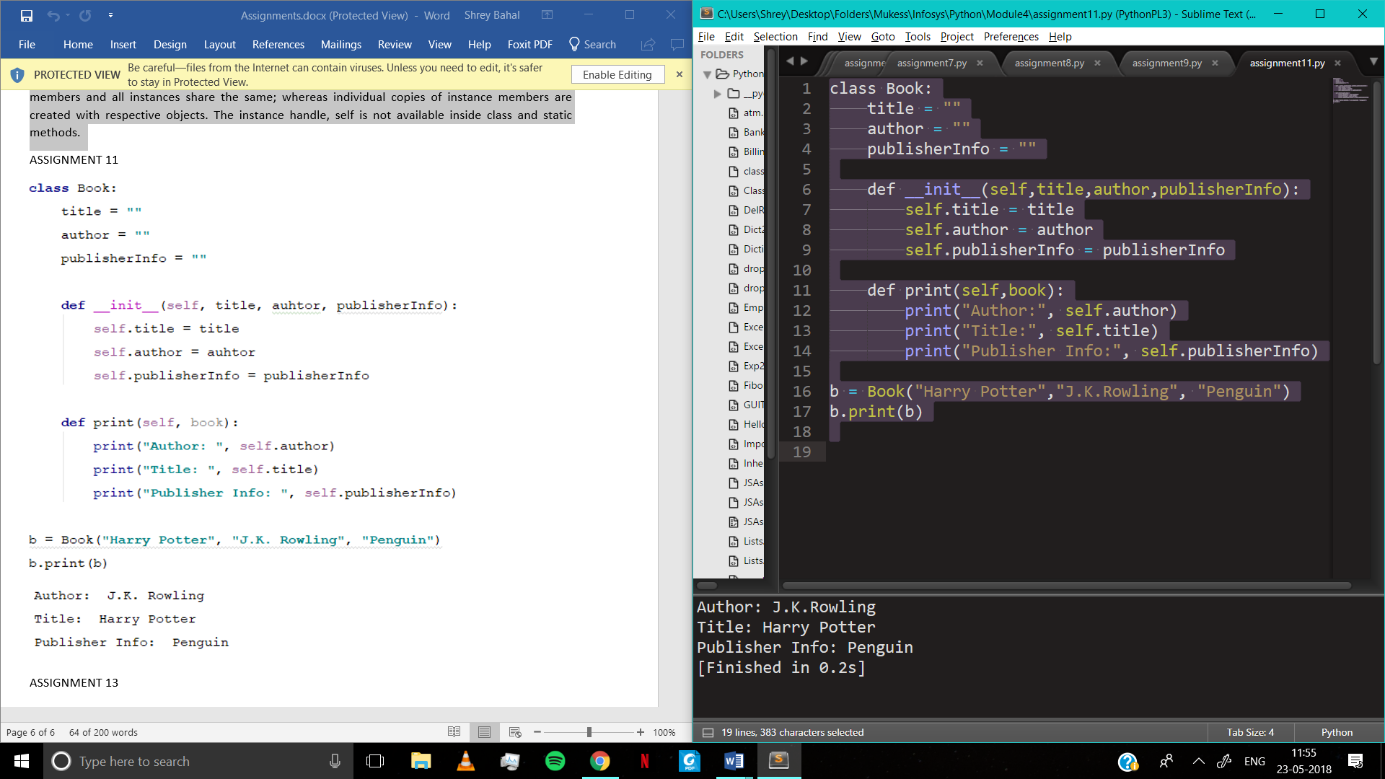

Assignment 12

class calculator:

def __init__(self, num):

self.lastprime = num

def nextPrime(self):

self.num = self.lastprime + 1

v=0

if (self.num > 1):

for i in range(2, self.num):

if((self.num % i) != 0):

v+=1

else:

break

if(v==self.num-2):

print(self.num, " is a prime number")

else:

# print(self.num, " is not a prime number")

pass

self.lastprime = self.num

self.num += 1

obj = calculator(2)

for i in range (230):

obj.nextPrime()

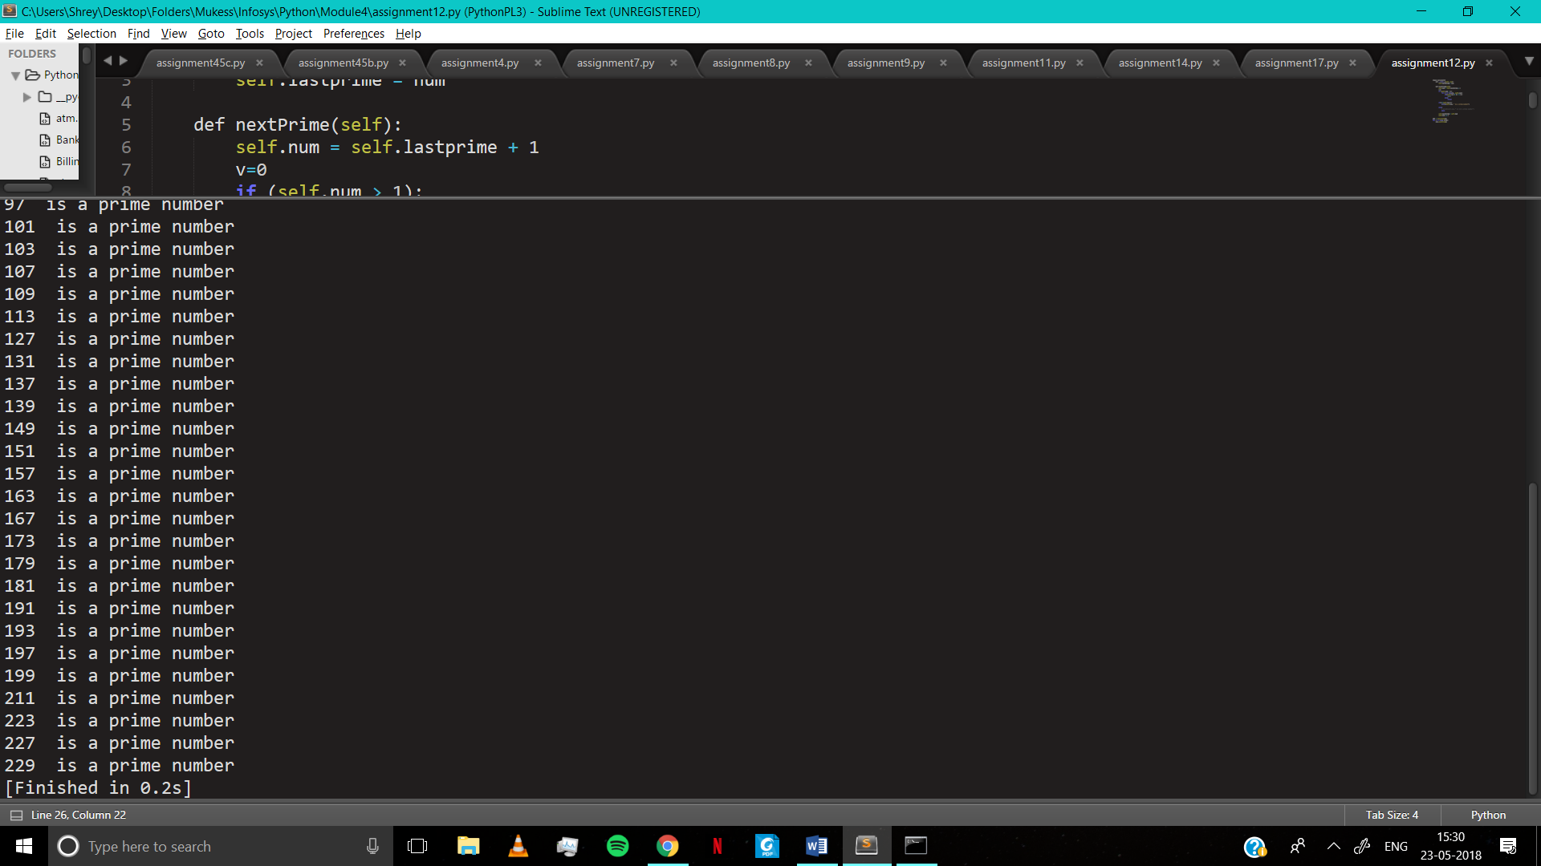

Assignment 13

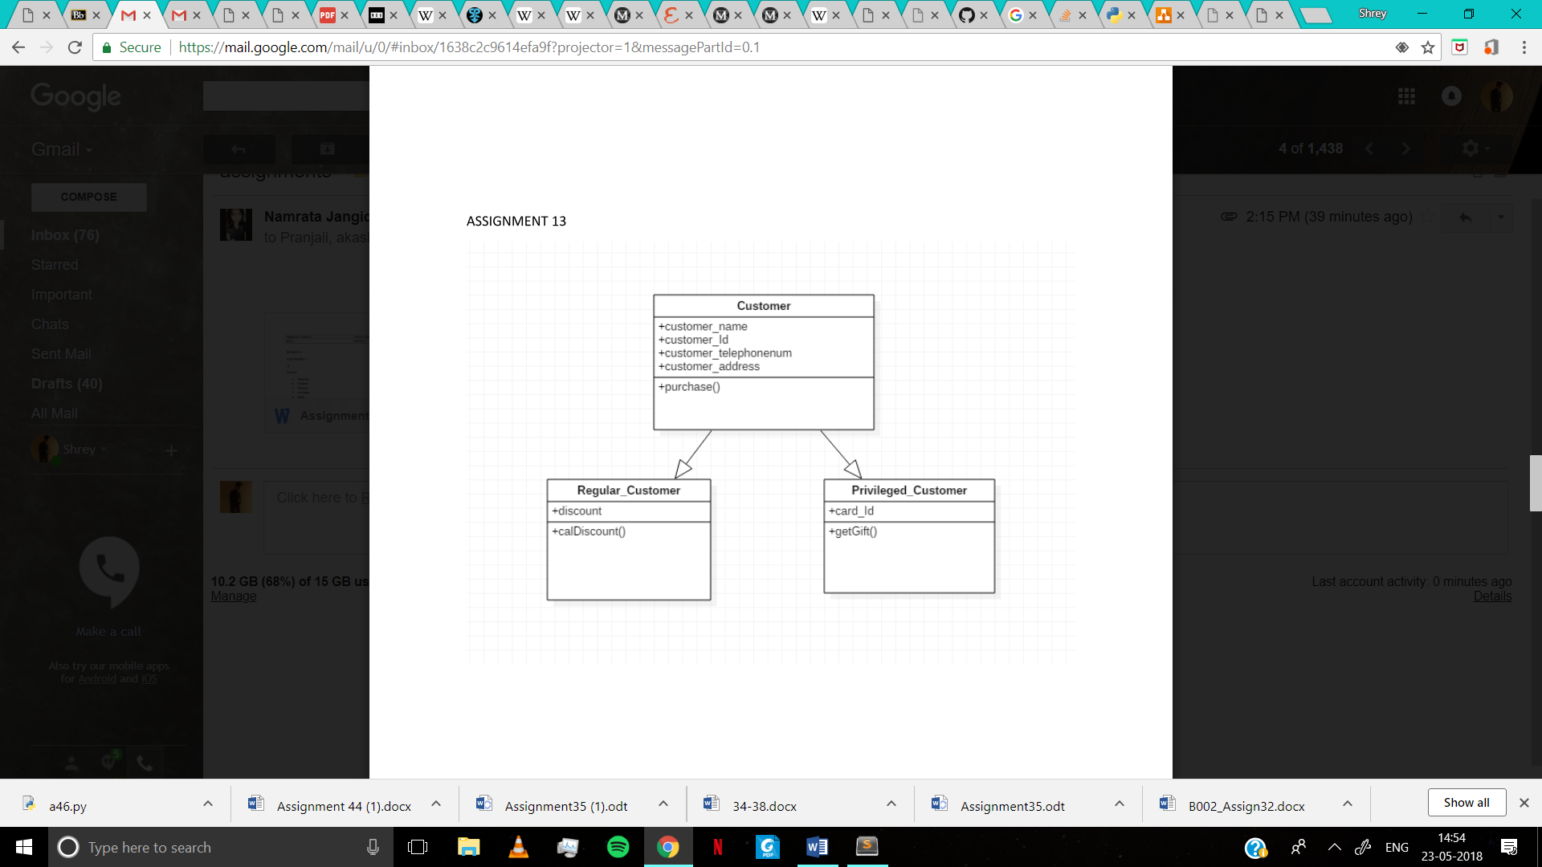

Assignment 14

class box:

def __init__(self, length,breadth,height):

self.length = length

self.breadth=breadth

self.height=height

def getVolume(self):

vol = self.length*self.breadth*self.height

return vol

class BigBox(box):

def __init__(self, length,breadth,height):

box.__init__(self, length, breadth, height)

self.capacity=box.getVolume(self)

def getCapacity(self,sbox):

self.capacity=self.capacity/sbox.getVolume()

return self.capacity

smallbox=box(1,1,1)

BigBox=BigBox(4,4,4)

capacity=BigBox.getCapacity(smallbox)

print("Capacity:", capacity)

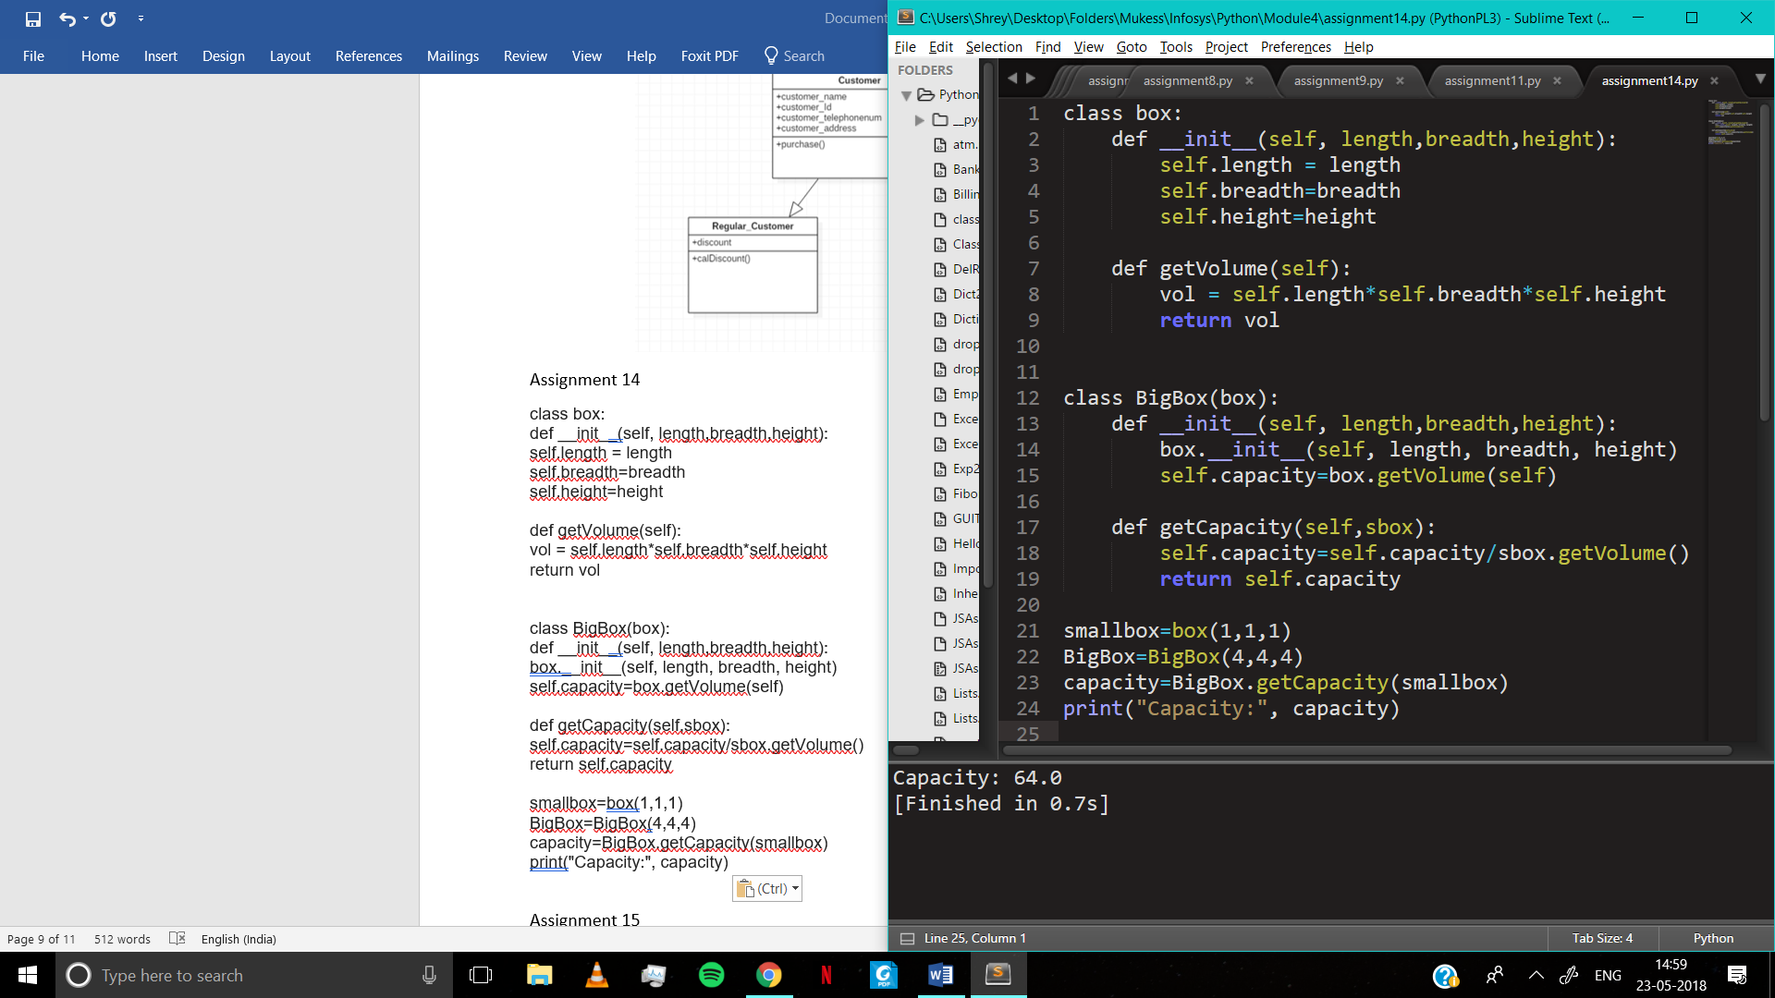

Assignment 15

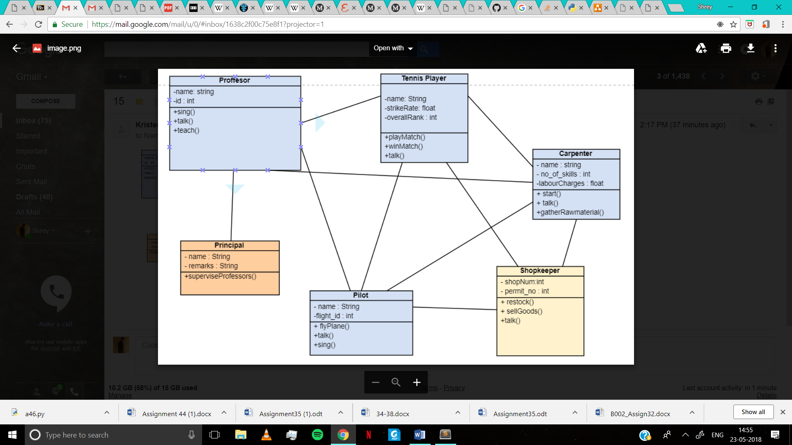

Assignment 16

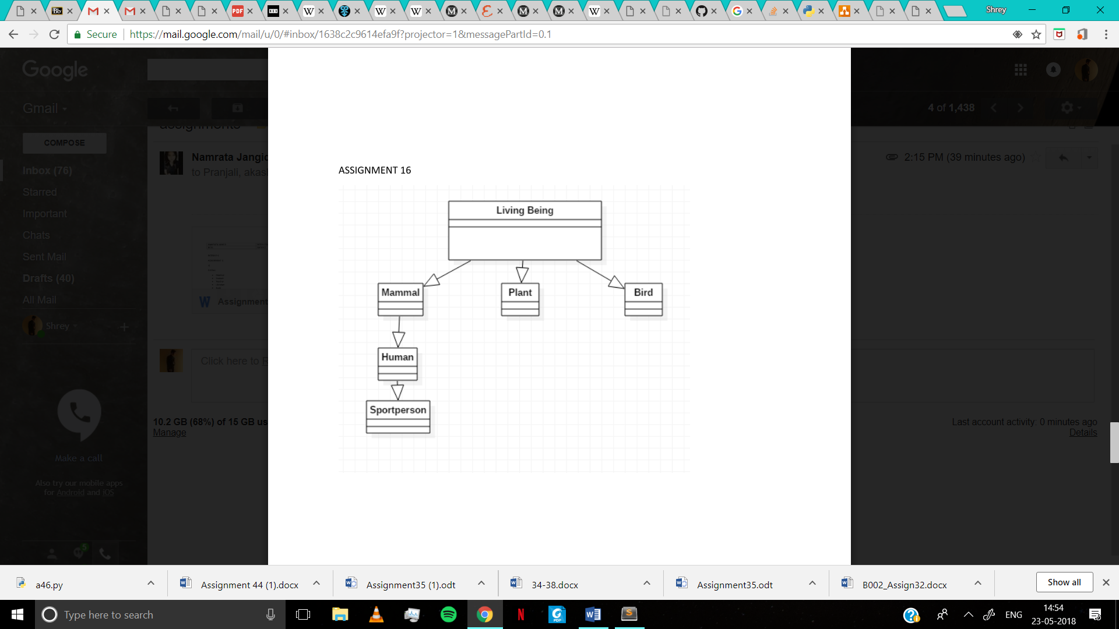

Assignment 17

class Employee:

def __init__(self,salary):

self.salary = salary

def getSalary(self,payday,lop):

pass

class Faculty:

def __init(self,remuneration):

self.remuneration = remuneration

def teach(self,course):

pass

class Visitor:

def __init__(self,remuneration):

self.remuneration = remuneration

def calculateFees(self,startTime, endTime):

pass

class Clerk(Employee):

def prepareBalanceSheet(self):

pass

class RegularFaculty(Faculty):

def prepareAttendanceReport(self):

pass

class VisitingFacult(Visitor):

def examine(self):

pass

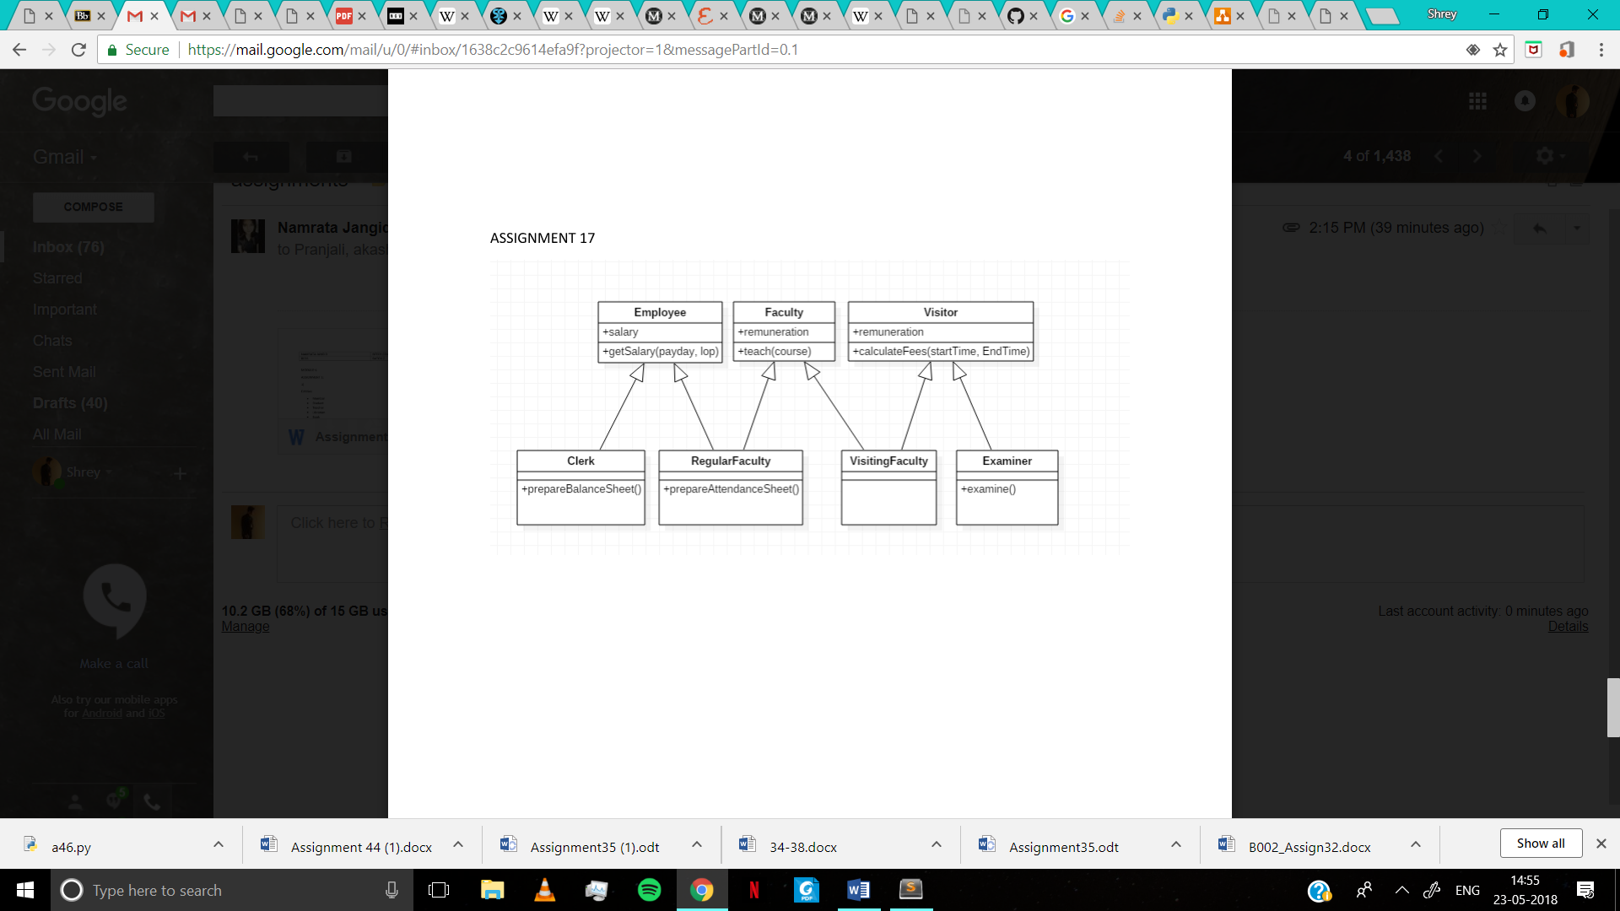

Assignment 18

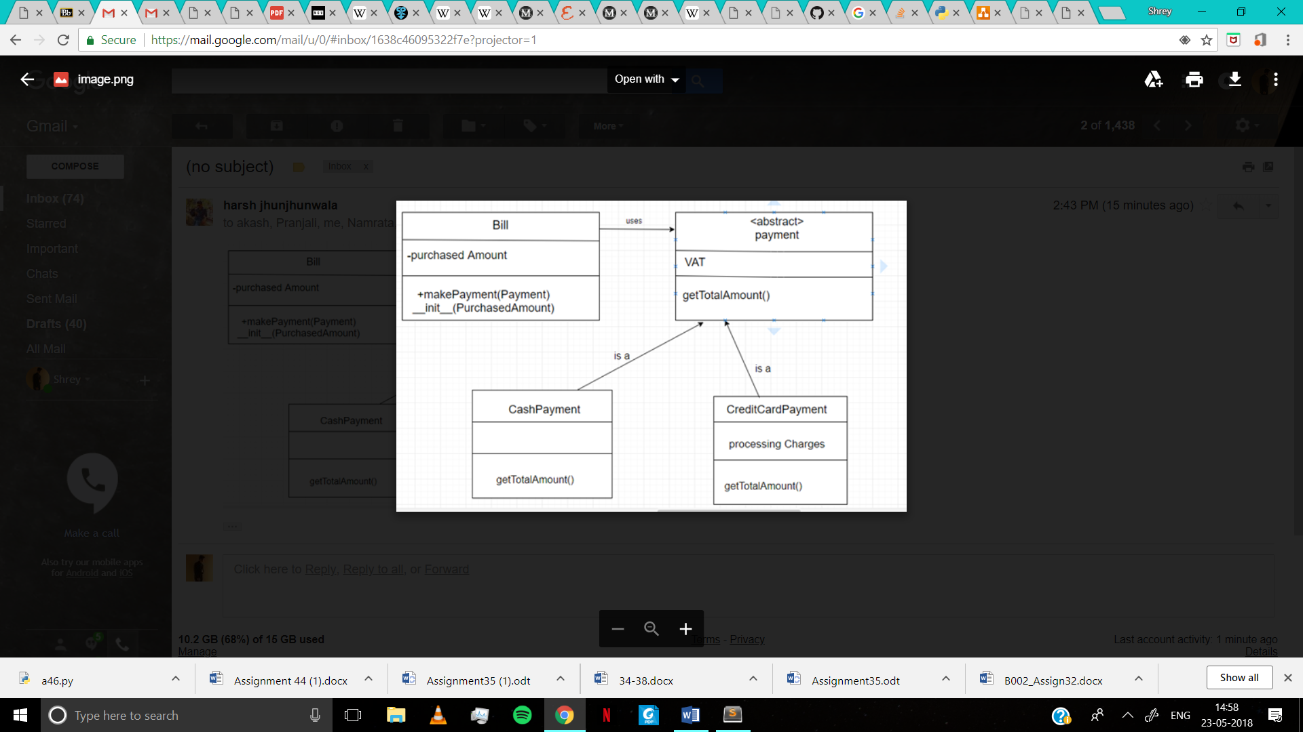

Assignment 19

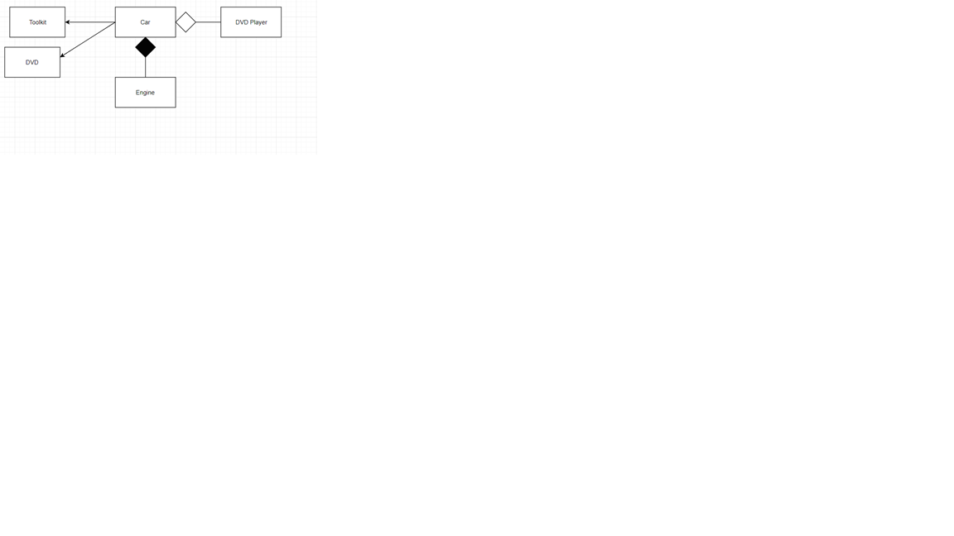

Assignment20

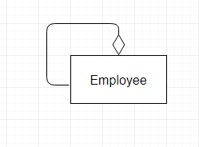

Assignment21

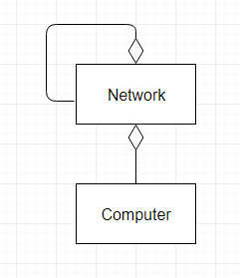

Assignment22

1.

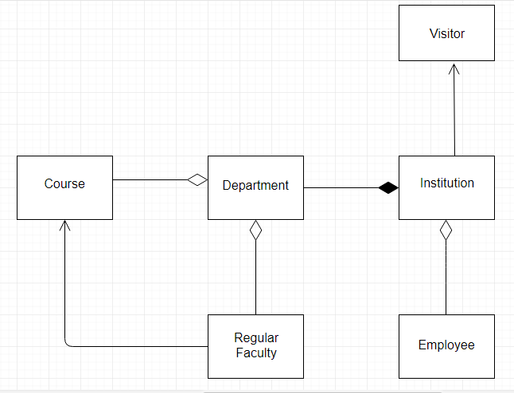

2.

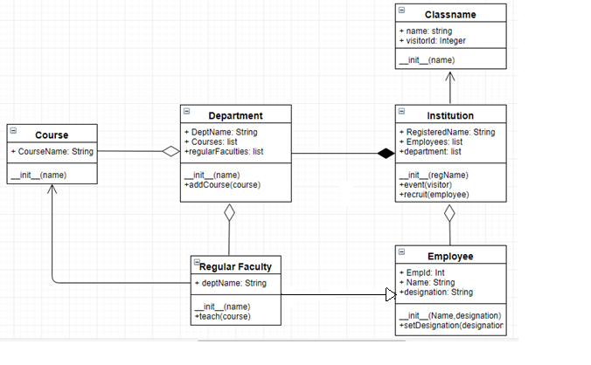

Assignment 23

class Faculty:

def addExpertise(self, course):

self.__coursesExpertise.append(course)

def __init__(self, name):

self.__name = name

self.__coursesExpertise = []

class Student:

def enroll(self, course):

self.__enrolledCourses.append(course)

def __init__(self, student_id):

self.__id = student_id

self.__enrolledCourses = []

class Course:

def registerStudent(self, student):

self.__registeredStudents.append(student)

def registerExpert(self, faculty):

self.__expertFaculties.append(faculty)

def __init__(self, name):

self.__name = name

self.__registeredStudents = []

self.__expertFaculties = []

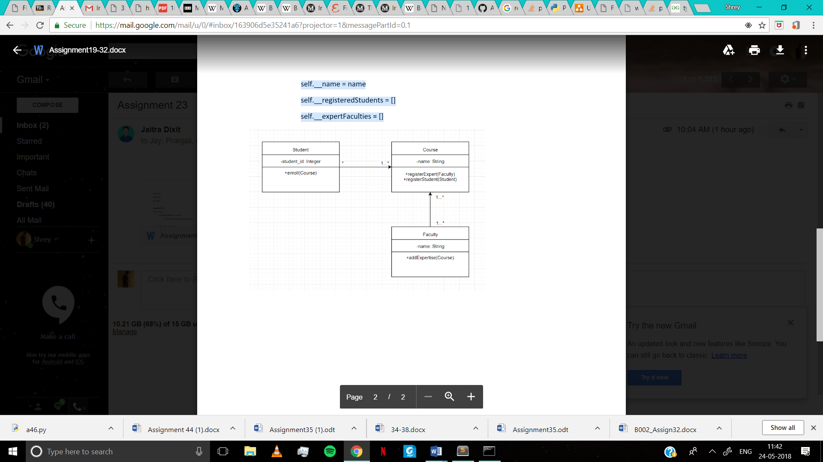

Assignment24

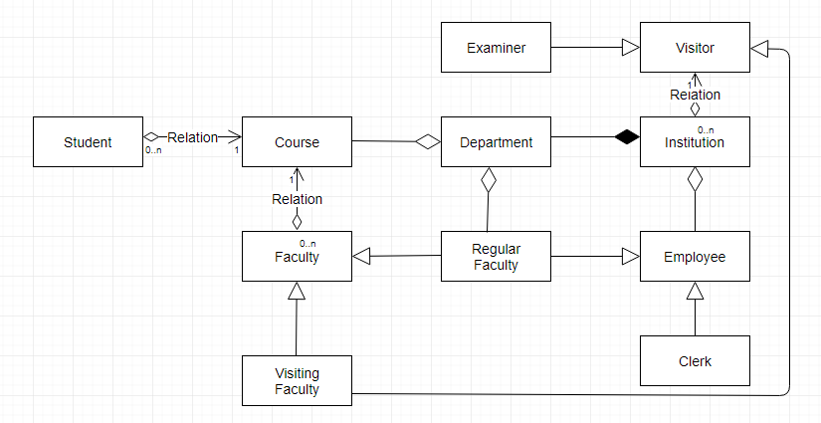

Assignment 25

class Employee():

# def __init__(self,FirstName,LastName,Pay):

def __init__(self,EmpId,FirstName,Designation):

self.EmpId = EmpId

self.first = FirstName

self.desig = Designation

# self.last = LastName

# self.salary = Pay

# self.email = self.first + '.' + self.last + '@company.com'

def details(self):

print(self.EmpId,self.first,self.desig)

class Department():

def __init__(self,DeptName):

self.dept = DeptName

def getDept(self):

print(self.dept)

class RegularFaculty(Employee,Department):

def __init__(self,EmpId,first,desig,dept):

Employee.__init__(self,EmpId,first,desig)

Department.__init__(self,dept)

# self.id = EmpId

# self.first = FirstName

# self.desig = Designation

# self.dept = DeptName

# class RegularFaculty(Department,Employee):

# def __init__(self,EmpId,FirstName,Designation,DeptName):

def getRegularFaculty(self):

print(self.EmpId,self.first,self.dept,self.desig)

class Visitor():

# def __init__(self,FirstName,LastName,Pay):

def __init__(self,VName):

self.VName = VName

def getVName(self):

print(self.VName)

class Institution(Employee,Department):

def __init__(self,EmpId,first,desig,dept):

Employee.__init__(self,EmpId,first,desig)

Department.__init__(self,dept)

# def __init__(self,FirstName,LastName,Pay):

def __init__(self,InsName):

self.InsName = InsName

def getName(self):

print(self.VName)

def addDepartment(self,d1):

self.d1 = d1

print(self.d1,"is added")

d1 = Department('Computer')

d2 = d1.getDept()

e1 = Employee('1','John','Clerk')

e1.details()

e2 = Employee('2','Jack','Professor')

e3 = RegularFaculty('2','Jack','Computer','Professor')

e3.getRegularFaculty()

v1 = Visitor('Bill Gates')

inst=Institution('Institution of technology')

inst.addDepartment(d1.getDept())

# v1.getVName()

#emp_1.getEmail()

# emp_1.getFullName()

# emp_1.getPay()

# e1 = Employee(FirstName,Designation)

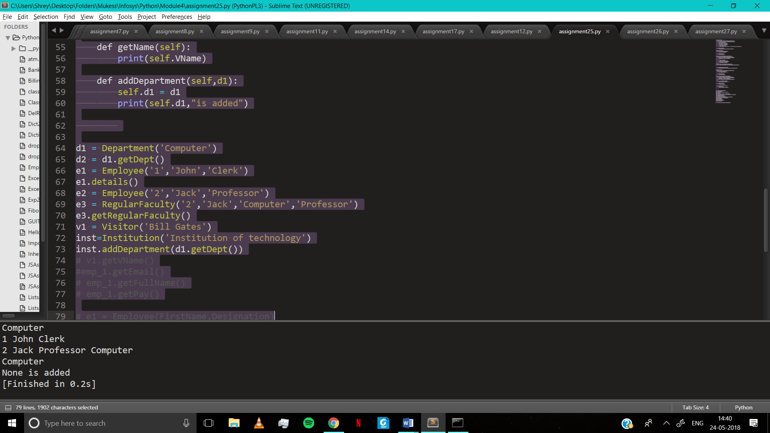

Assignment 26

class Error(Exception):

pass

class InvalidString(Error):

def __init__(self):

self.msg = "Found Aserisk"

def asteriskChecker(myString):

for i in myString:

if (i=="*"):

raise InvalidString

mymessage = "abcde*fz"

try:

asteriskChecker(mymessage)

except InvalidString as error:

print(error.msg)

else:

print("String has no asterisk")

`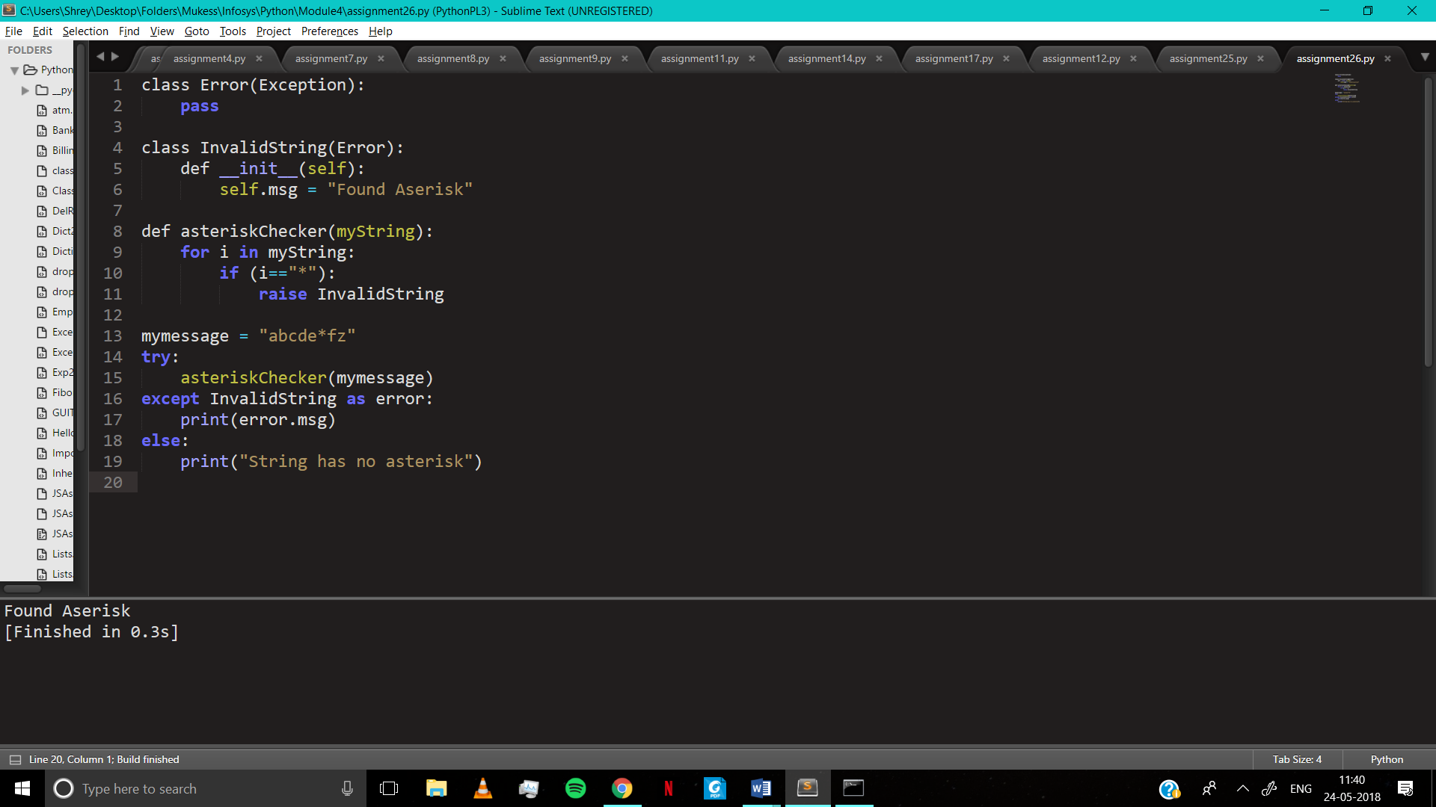

Assignment 27

1.

try:

file = open("C:\\Users\\jaitr\\Desktop\\College\\Sem 6\\Infosys Connect\\Module 4 OO Concepts\\a27_file.txt", "r")

print("File contains:\n")

print(file.read())

except IOError as error_message:

file.close()

print("File has been closed, since and IOError occurred.")

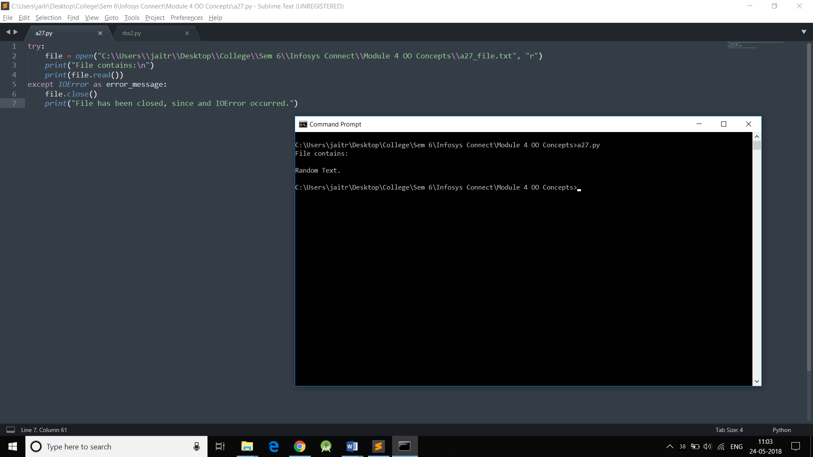



2.

try:

file = open("C:\\Users\\jaitr\\Desktop\\College\\Sem 6\\Infosys Connect\\Module 4 OO Concepts\\a27_file.txt", "r")

print("File contains:\n")

print(file.read())

file = open("C:\\Users\\jaitr\\Desktop\\College\\Sem 6\\Infosys Connect\\Module 4 OO Concepts\\a27_file.txt", "a")

file.write("\nHello")

print(filename.read())

except Exception:

file.close()

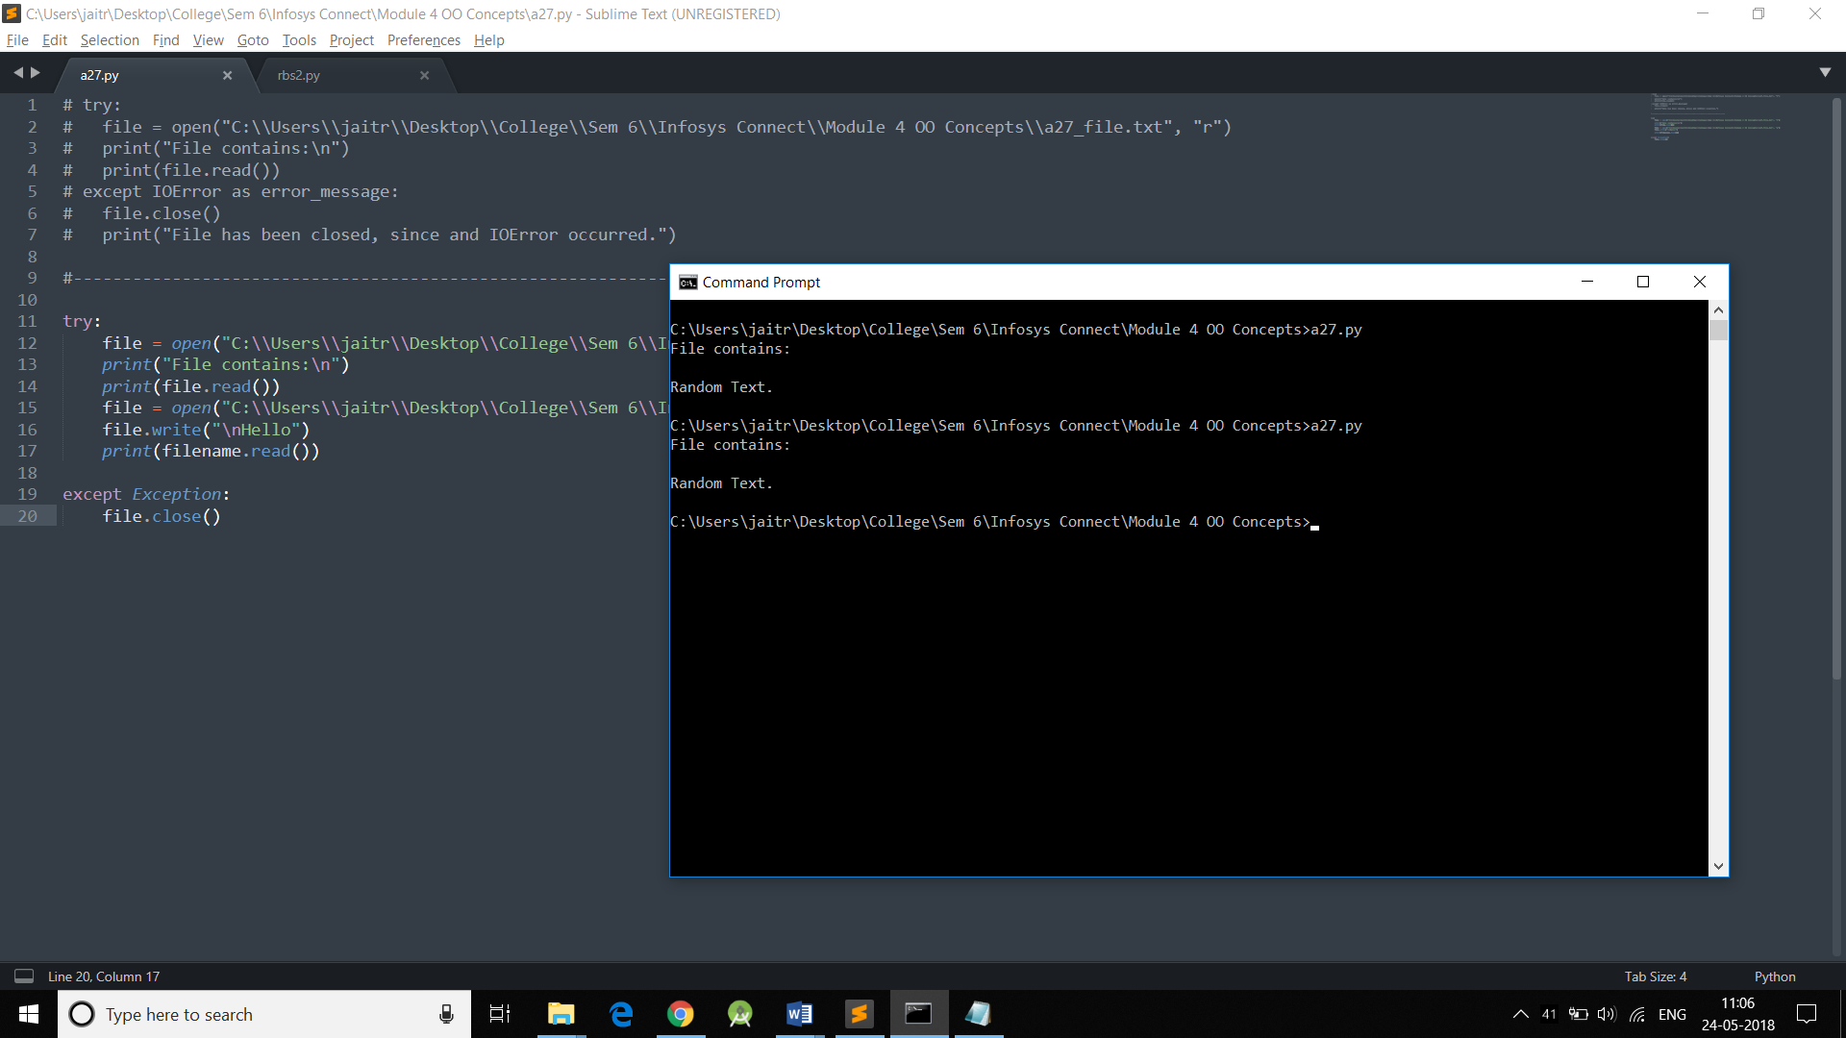

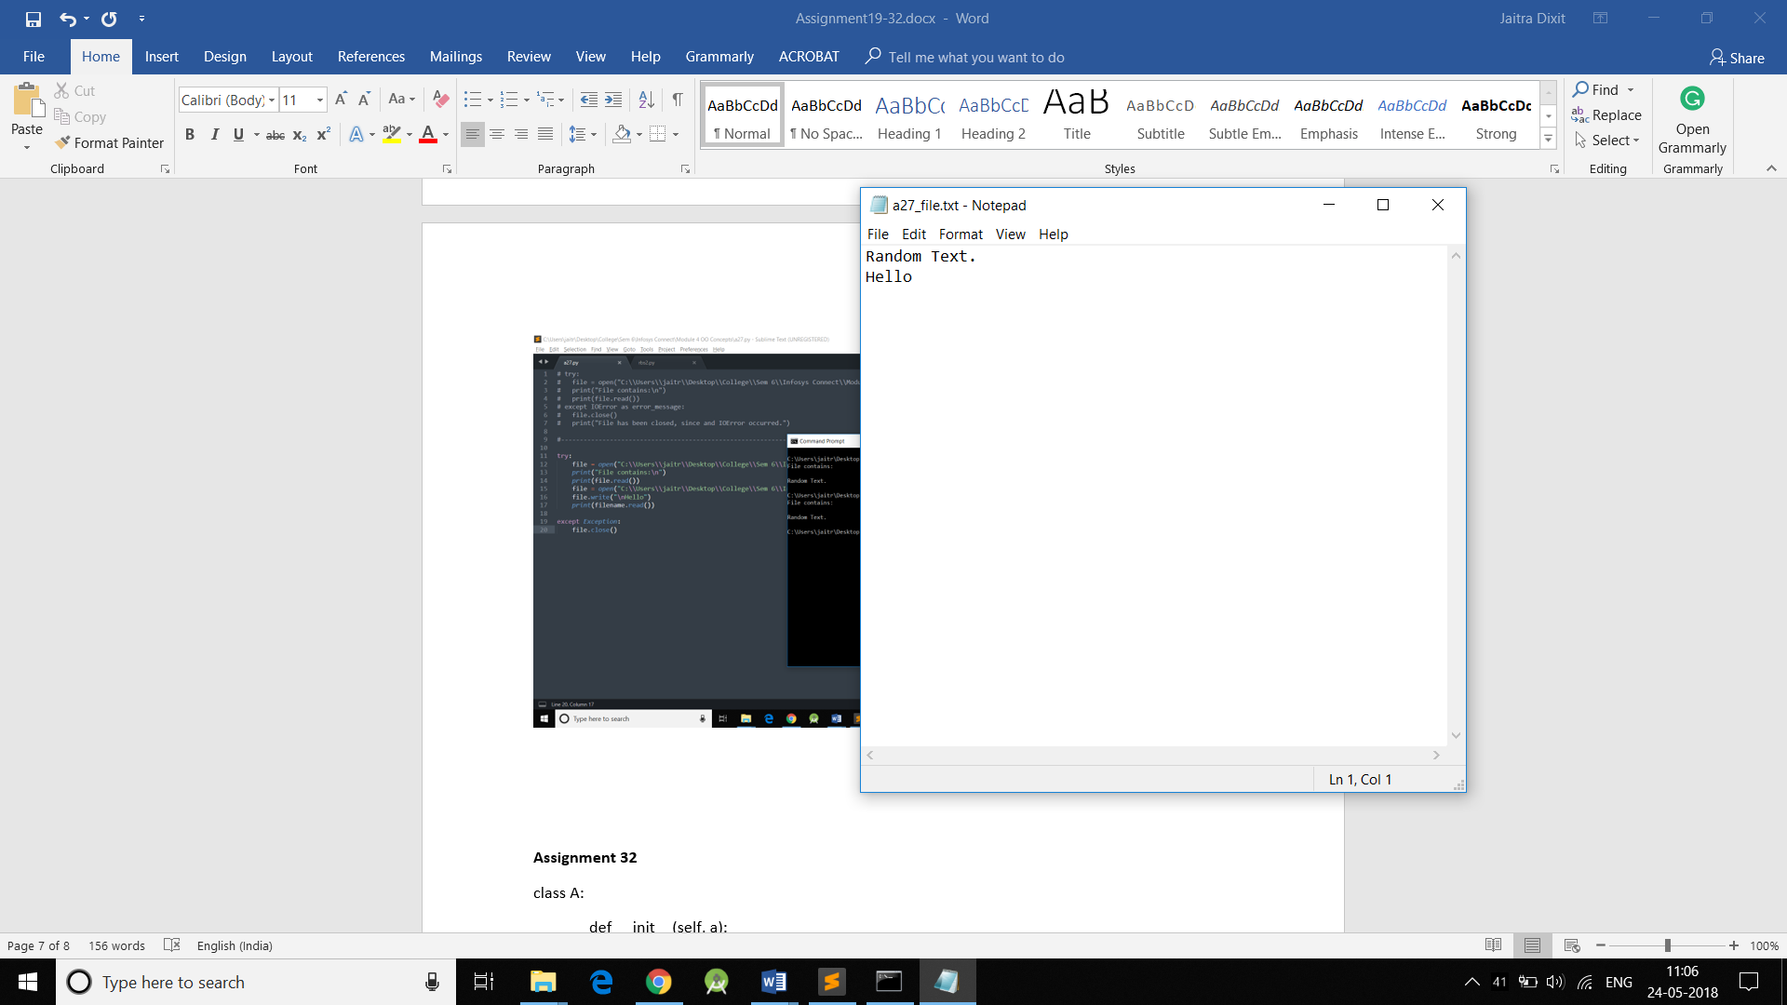

Assignment 28

1.

class Error(Exception):

pass

class invalidEmail(Error):

pass

class invalidAge(Error):

pass

class invalidNumber(Error):

pass

try:

email = input("Enter the email ID: ")

mobile_no = input("Enter the mobile number: ")

age = int(input("Enter the age: "))

if(age<0 or age>101):

raise invalidAge

else:

print("\nAge: ", age)

dot_count = 0

at_count = 0

for ch in email:

if(ch == "."):

dot_count = dot_count + 1

elif(ch == "@"):

at_count = at_count + 1

if(dot_count>=1 and at_count == 1):

print("Email ID: ", email)

else:

raise invalidEmail

if(len(mobile_no) == 10 or len(mobile_no) == 11):

if(mobile_no.isdigit() == True):

print("Mobile Number: ", mobile_no)

elif(len(mobile_no) == 11 and mobile_no[0] == "+"):

print("Mobile Number:", mobile_no)

else:

raise invalidNumber

else:

raise invalidNumber

except invalidEmail:

print("Email ID is invalid")

except invalidAge:

print("Age is invalid")

except invalidNumber:

print("Number is invalid")

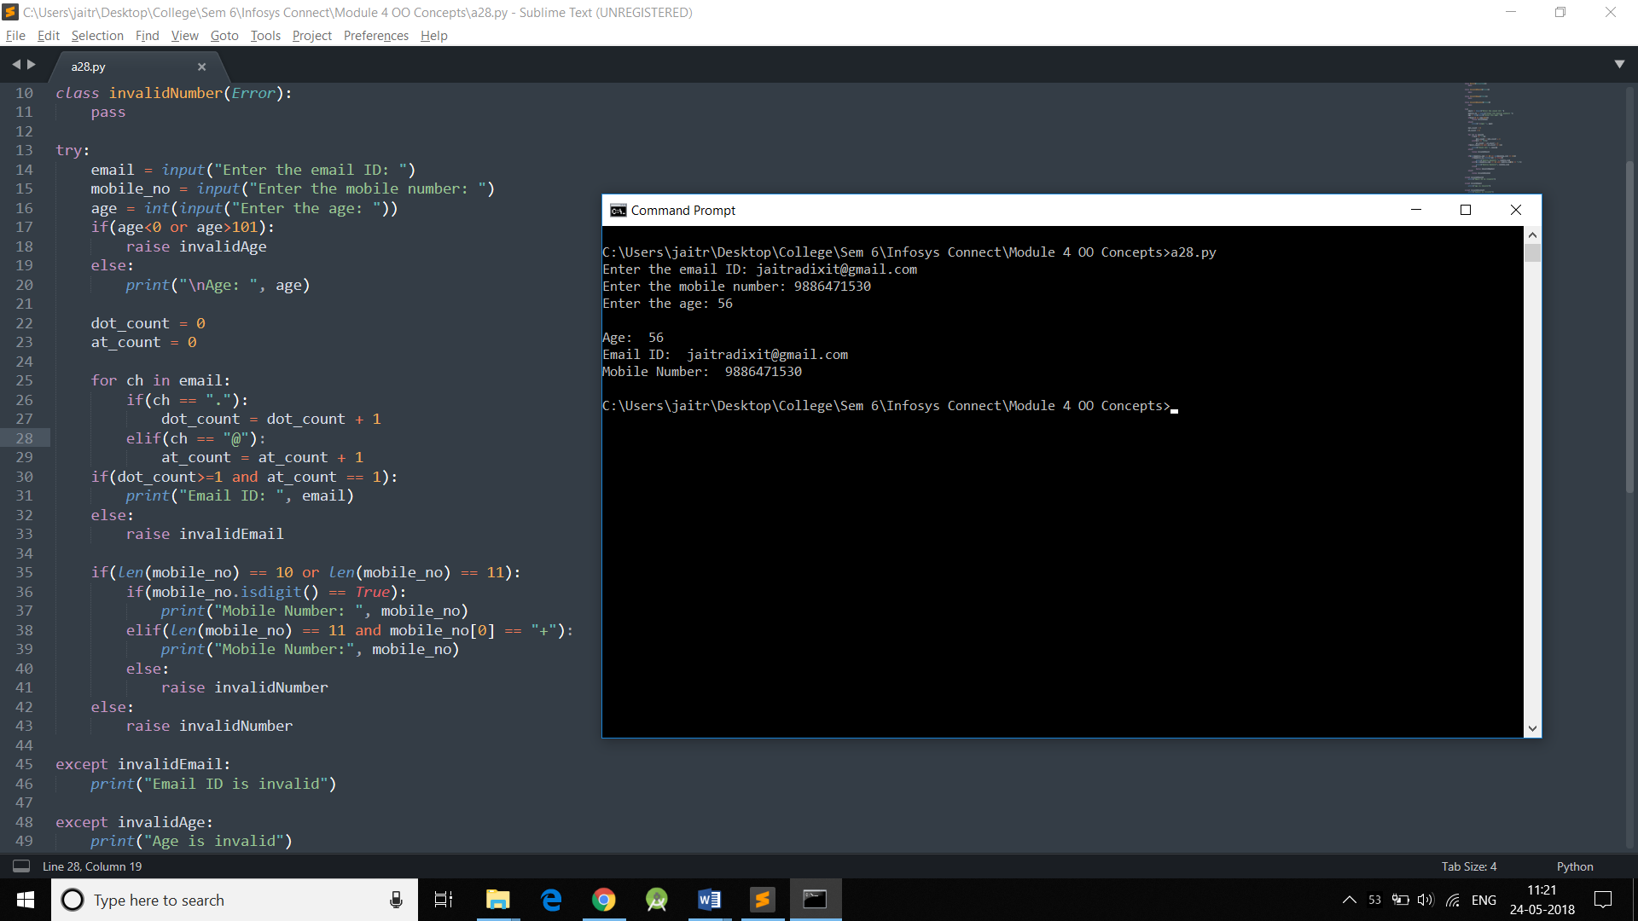

Assignment 29

|  |  |  |
| --- | --- | --- |
| **Test Case** | **Description** | **Expected Discount** |
| 1 | Customer age<60 : 59 | 0 |
| 2 | Customer age=60 :60 | 15% |
| 3 | Customer age>60 :61 | 15% |
| 4 | Customer age<70 :69 | 15% |
| 5 | Customer age=70 :70 | 30% |
| 6 | Customer age>70 :71 | 30% |

Assignment 30

|  |  |  |  |  |
| --- | --- | --- | --- | --- |
| **Test Case** | **Description** | **Expected Discount** | **Actual Discount** | **Result**  **Pass/Fail** |
| 1 | Customer age<60 : 59 | 0 | 0 | Pass |
| 2 | Customer age=60 :60 | 15 | 0 | Fail |
| 3 | Customer age>60 :61 | 15 | 15 | Pass |
| 4 | Customer age<70 :69 | 15 | 15 | Pass |
| 5 | Customer age=70 :70 | 30 | 0 | Fail |
| 6 | Customer age>70 :71 | 30 | 30 | Pass |

a30.py

def getDiscount(age):

discount = 0

if (age>60 and age<70):

discount = 15

elif (age > 70):

discount = 30

return discount

test_a30.py (For testing)

import a30

def test_getDiscount():

for i in range (0, 81, 10):

discount = a30.getDiscount(i)

assert discount == 0

print(discount)

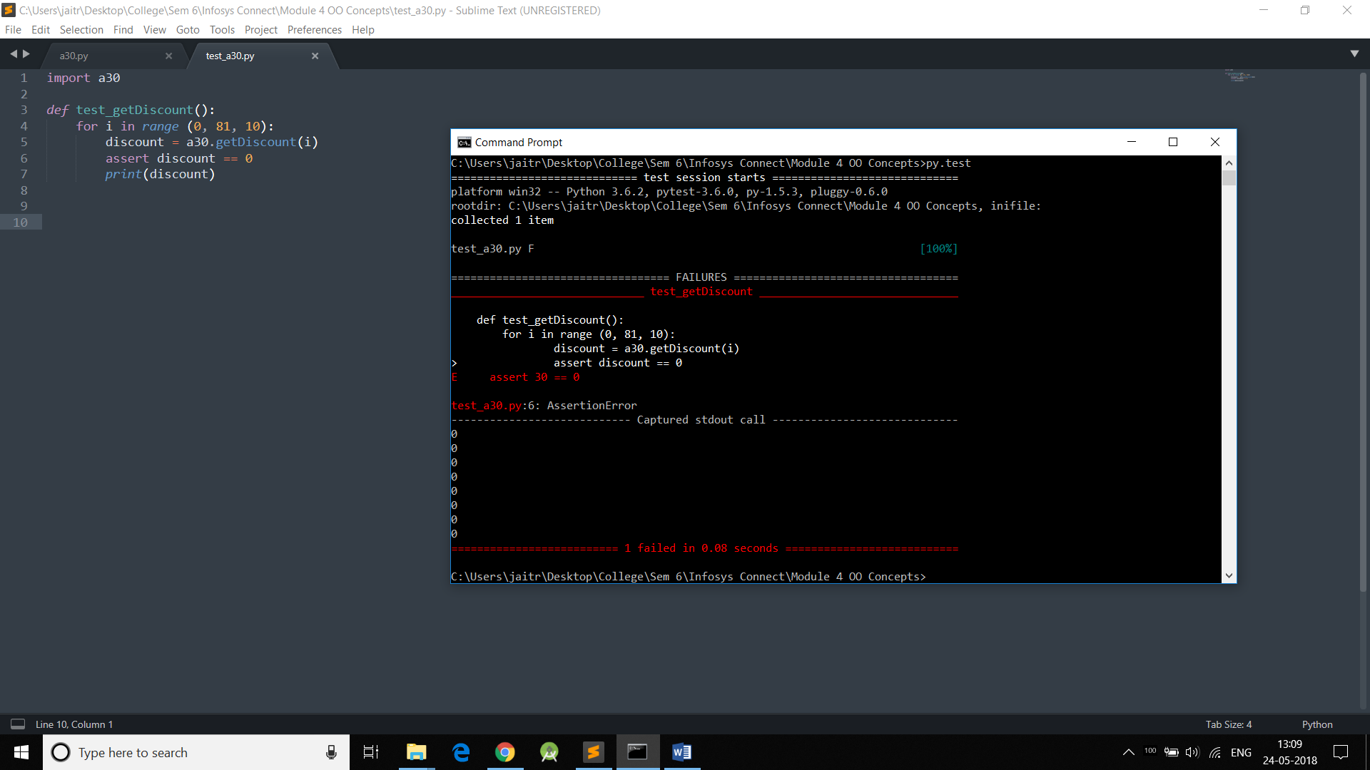

Assignment 31

|  |  |  |  |  |
| --- | --- | --- | --- | --- |
| **Test Case** | **Description** | **Expected Discount** | **Actual Discount** | **Result**  **(Pass/Fail)** |
| 1 | age<60, gender=’F’ | 15 | 15 | Pass |
| 2 | age=60, gender=’F’ | 25 | 20 | Fail |
| 3 | age<60, gender=’M’ | 0 | 0 | Pass |
| 4 | age=60, gender=’M’ | 20 | 20 | Pass |

a31.py

def getDiscount(age, gender):

discount = 0

if age >= 60:

if (gender == "F"):

discount = 25

discount = 20

elif (gender == "F"):

discount = 15

return discount

test_a31.py

import a31

def test_getDiscount():

for i in range (0, 61, 10):

discount = a31.getDiscount(i, "F")

assert discount == 15

print(discount)

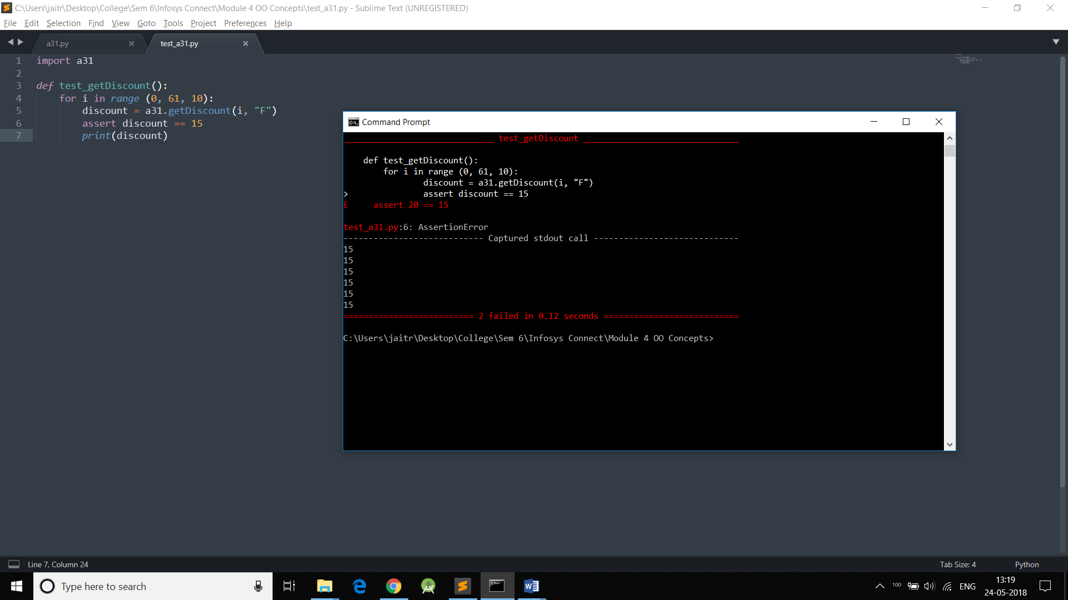

Assignment 32

class A:

def __init__(self, a):

self.a = a

class B(A):

def __init__(self, a, b):

super().__init__(a)

self.b = b

class C(B):

def __init__(self, a, b, c):

super().__init__(a,b)

self.c = c

def printvalues(self):

print(self.a)

print(self.b)

print(self.c)

obj = C(1,2,3)

obj.printvalues()

